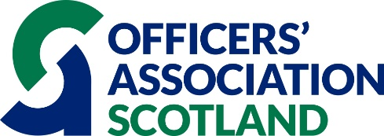

GRANTS TO VETERANS’ ORGANISATIONS IN SCOTLAND – 2023

Officers Association Scotland (OAS) is a military charity based in Scotland which provides lifelong welfare and employment support for serving, and former military officers and their families.

Scotland’s OA is delighted to announce the opening of our new funding round for 2023. It is looking to support Scottish charities who assist veterans generally, but which must either include officers and their dependents based in Scotland among the beneficiaries or have the potential to do so.

The Funding on offer is for Revenue or Captial costs over one or multiple years.
The funding options shall consist of:
- £25,000 for one year
- £15,000 a year for 2 years
- £10,000 a year for 3 years

The Charity Executive will review and assess all applications, and make site visits or conduct interviews as necessary, before recommendations and decisions are made by the Grants & Bursary Committee. They will consider a range of factors including the service or item being applied for, the number of beneficiaries, the importance of the grant to the applicant charity, any elements of partnership working and the needs of the beneficiaries.
All applicants will be sent an email acknowledgement of receipt of their application, as well as notification of how their application has fared, once a decision has been made.

Grants are restricted to organisations which are recognised as charitable by the Office of the Scottish Charity Regulator (OSCR) or the Charity Commission for England and Wales. Grants are made in good faith but progress reports on the use of the donation will be required from recipients along with copies of the latest accounts for as long as a particular donation is valid. On occasions, follow up visits may be required to view progress.

If you would like to apply for support from OA Scotland then please visit our website to download our application form. Once completed, please submit it by email to info@oascotland.org.uk .Please contact Heather McVeigh, Chief Executive, if you have any questions at all about the application process. h.mcveigh@oascotland.org.uk Tel: 0131 550 1575.

The application process shall close on 22nd September 2023. Decisions shall then be made in October with awards being distributed in November 2023.

